Vāstu Alignment as a Remedy
When space is aligned, life flows with less resistance.
Vāstu is not merely about structure—it is about creating harmony between space and life.
When your surroundings are aligned with natural directional energies, it supports clarity, stability, and prosperity.

दिशासु सम्यग्विन्यस्ते वास्तु शान्तिः प्रजायते ।
तस्मात् सुसंस्थिते देशे सुखं समृद्धिर्विवर्धते ॥

📖 Transliteration
Diśāsu samyag-vinyaste vāstu śāntiḥ prajāyate
Tasmāt susaṁsthite deśe sukhaṁ samṛddhir vivardhate

📖 Meaning
“When space is properly aligned in all directions, harmony arises.
In a well-balanced environment, happiness and prosperity naturally grow.”

🧭 IMPORTANCE OF VĀSTU AS A REMEDY
🕉️ Core Principle
Vāstu aligns the external environment to support internal karma

🔑 Why Vāstu is important
1️⃣ Space influences results
Even with a strong horoscope:
👉 improper space → delayed or reduced results
👉 aligned space → smoother outcomes

2️⃣ Each direction governs a life area
🧭 AṢṬA DIK – DIRECTIONS & LIFE AREAS

🌅 1️⃣ EAST (पूर्व – Indra)

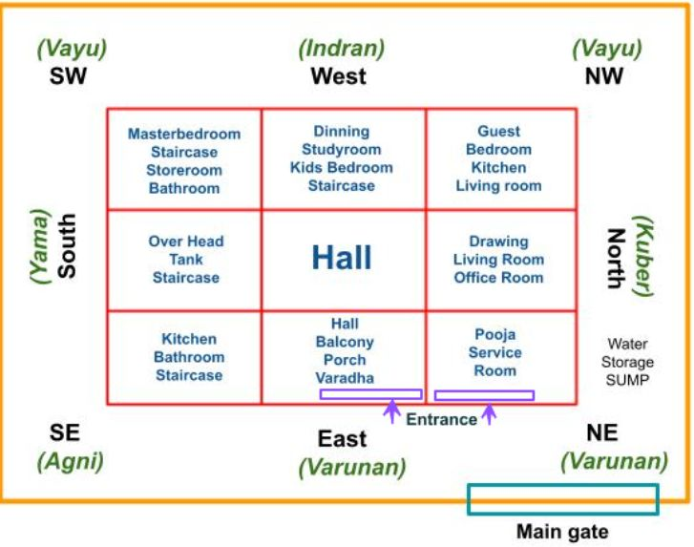
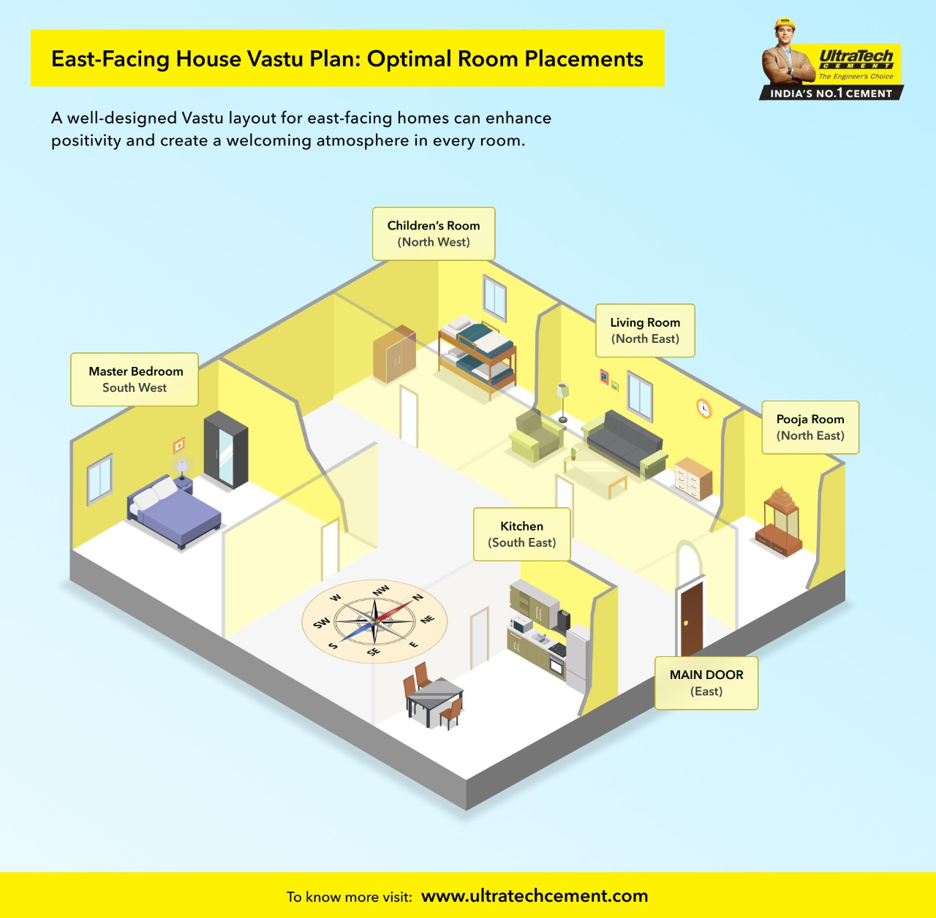
4
Governs:
- growth
- reputation
- opportunities
- vitality
Element:
Sun / light
If imbalanced:
- lack of recognition
- low confidence
- slow progress

🔥 2️⃣ SOUTHEAST (अग्नेय – Agni)
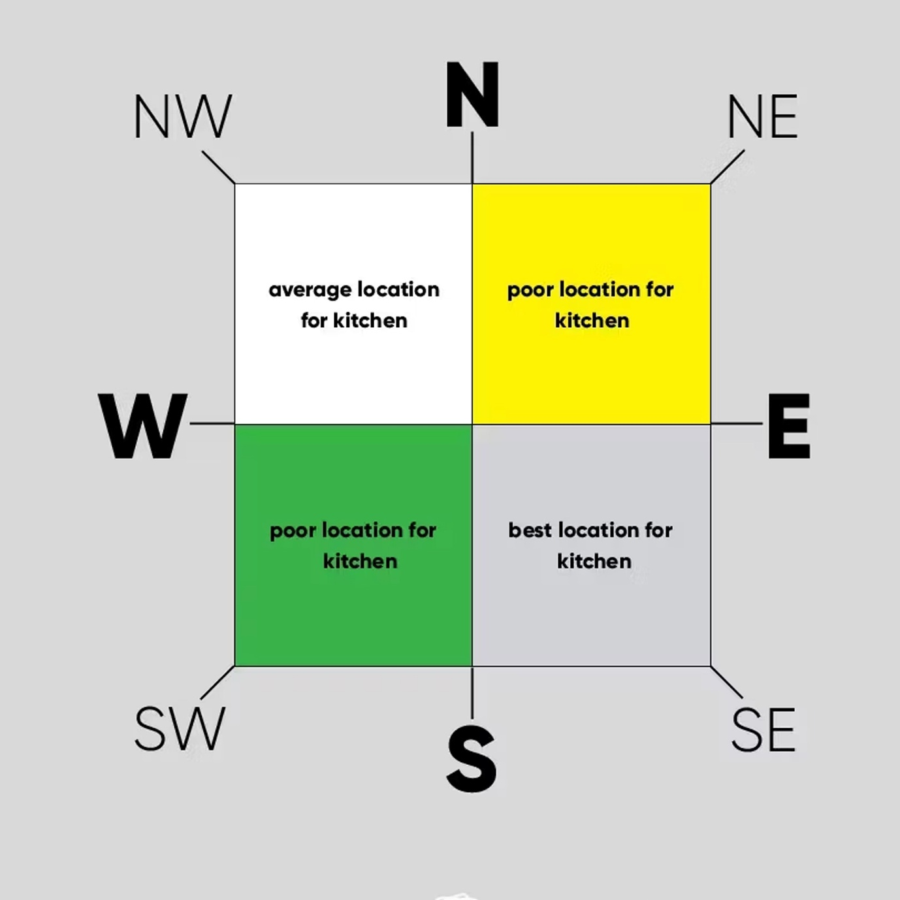

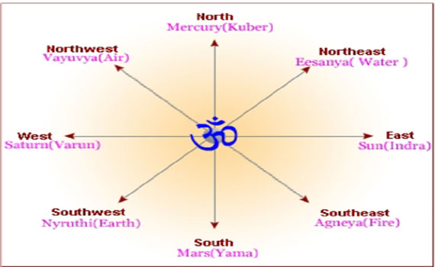
4
Governs:
- energy
- health
- digestion
- finances (cash flow)
Element:
Fire
If imbalanced:
- health issues
- anger
- financial instability

🪨 3️⃣ SOUTH (दक्षिण – Yama)
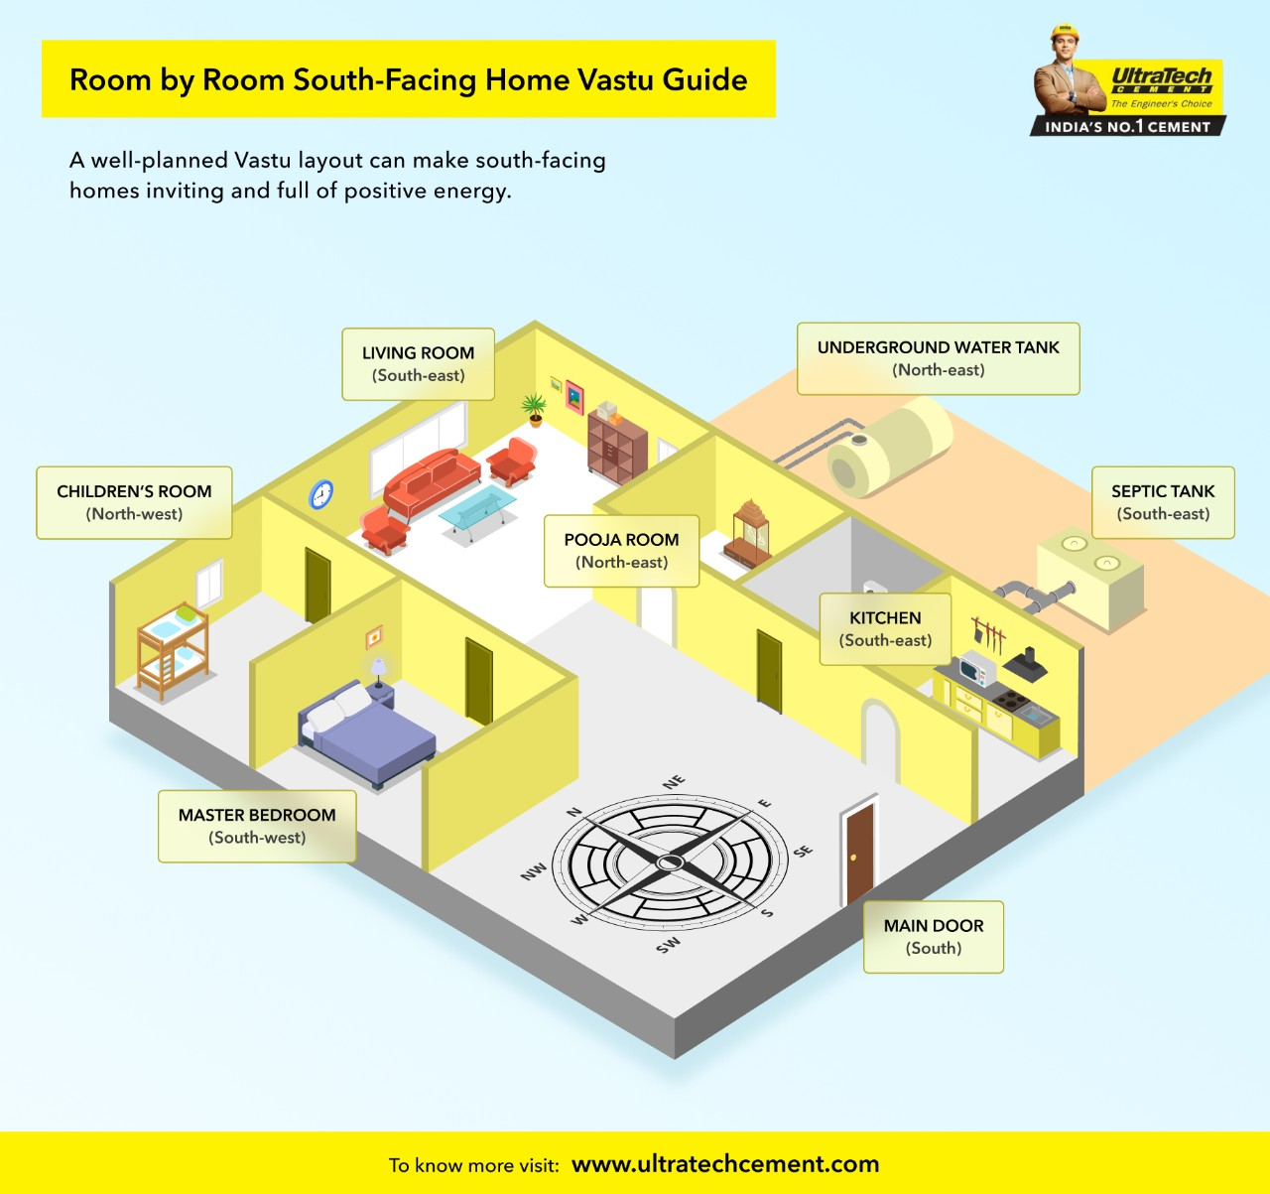
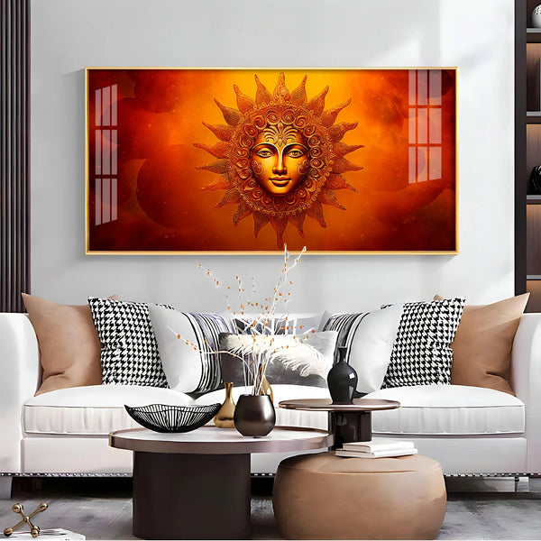
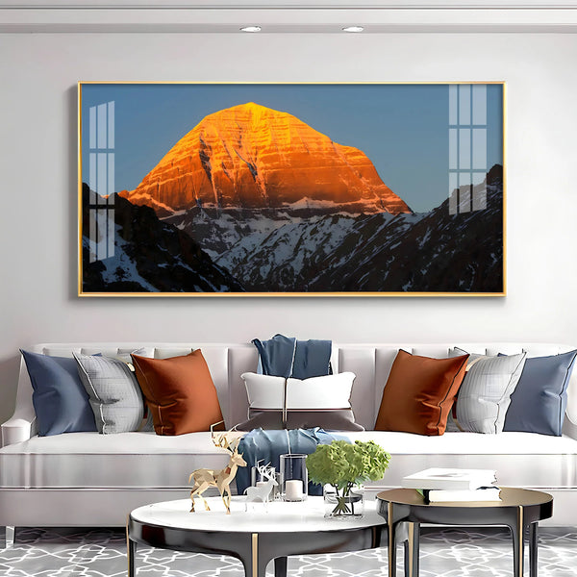
Governs:
- discipline
- control
- longevity
- career stability
Element:
Earth + heat
If imbalanced:
- fear
- instability in career
- lack of control

⚫ 4️⃣ SOUTHWEST (नैऋत्य – Nairṛti)

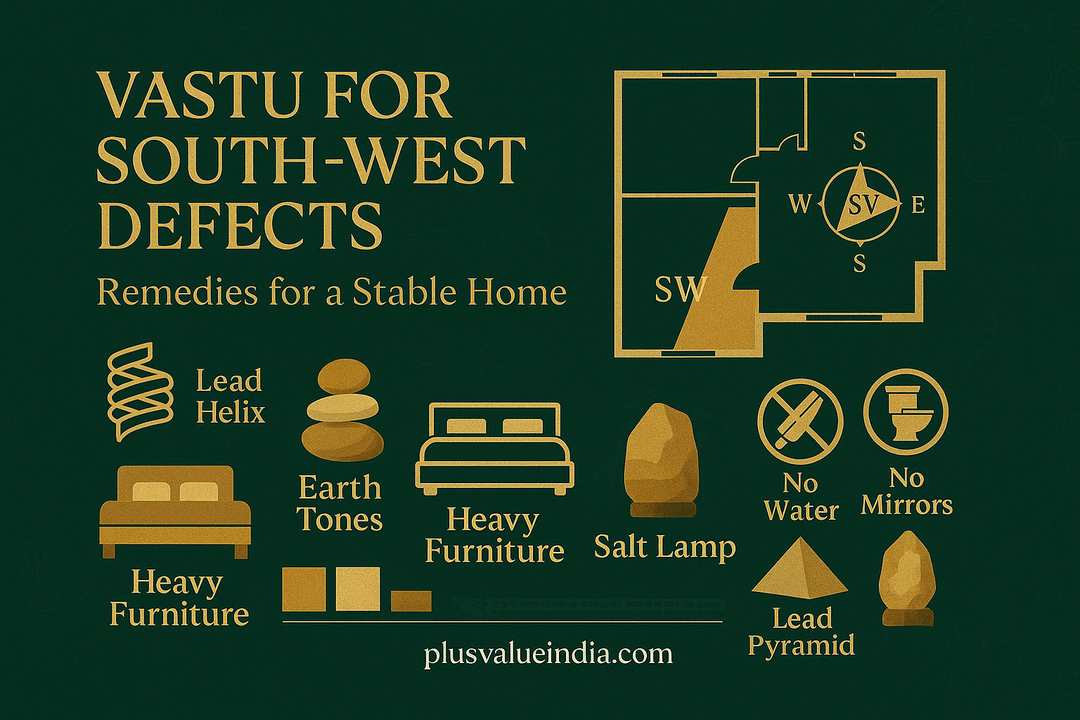
4
Governs:
- stability
- relationships
- long-term success
Element:
Earth
If imbalanced:
- instability
- relationship issues
- financial insecurity

🌊 5️⃣ WEST (पश्चिम – Varuna)
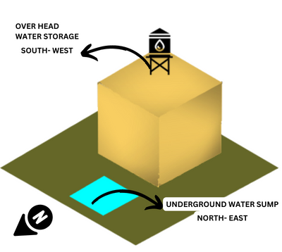

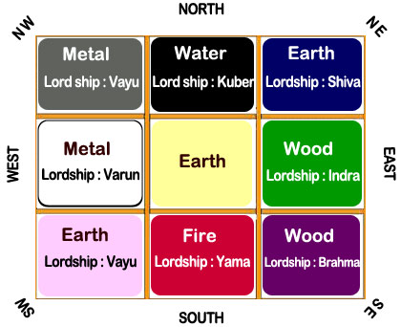
4
Governs:
- emotions
- gains
- fulfillment
- results of effort
Element:
Water
If imbalanced:
- delayed results
- emotional stress
- dissatisfaction

🌬️ 6️⃣ NORTHWEST (वायव्य – Vayu)
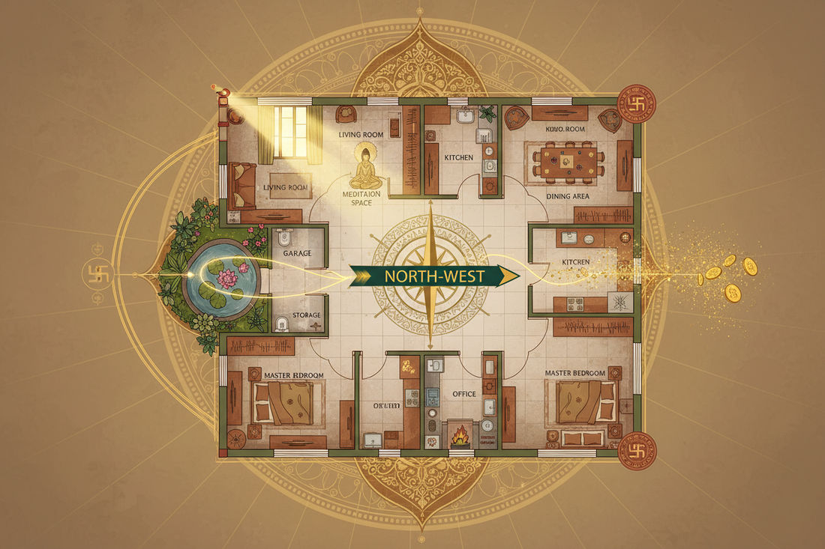
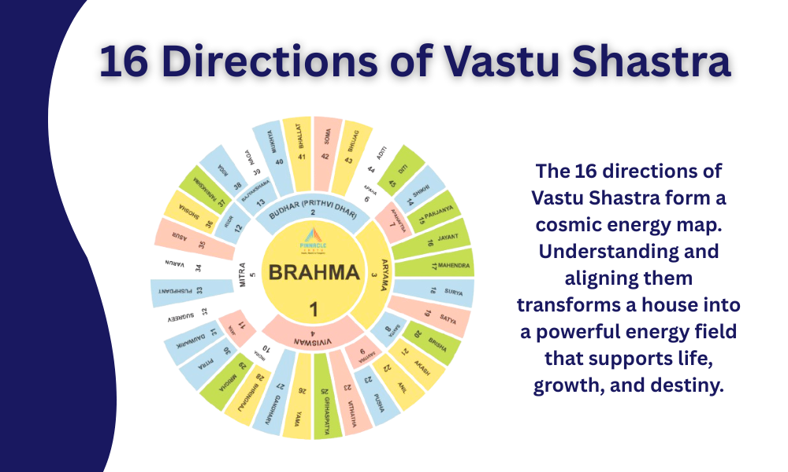

4
Governs:
- movement
- travel
- relationships (social)
- change
Element:
Air
If imbalanced:
- instability
- frequent changes
- anxiety

💰 7️⃣ NORTH (उत्तर – Kubera)
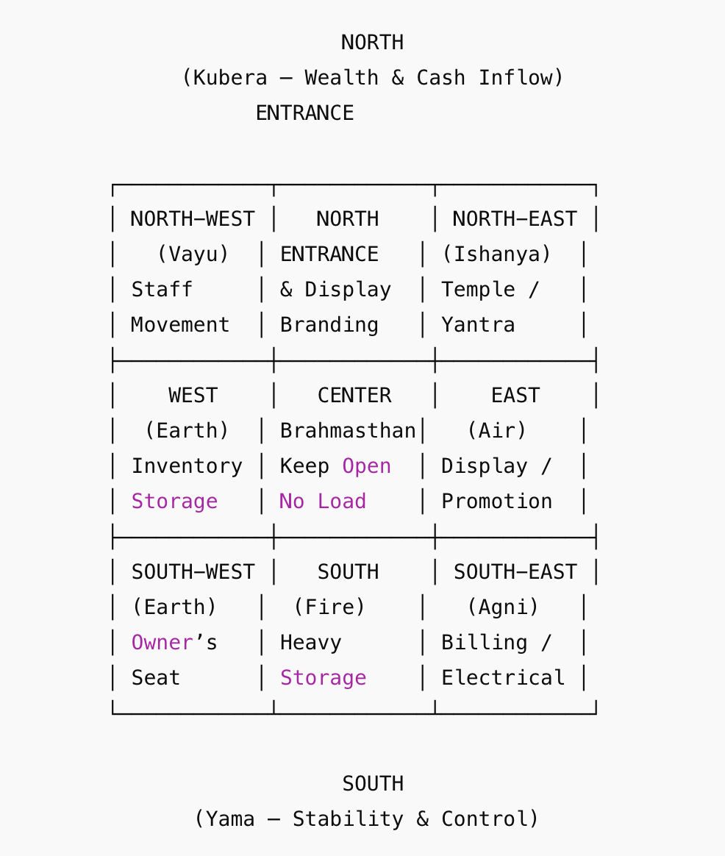
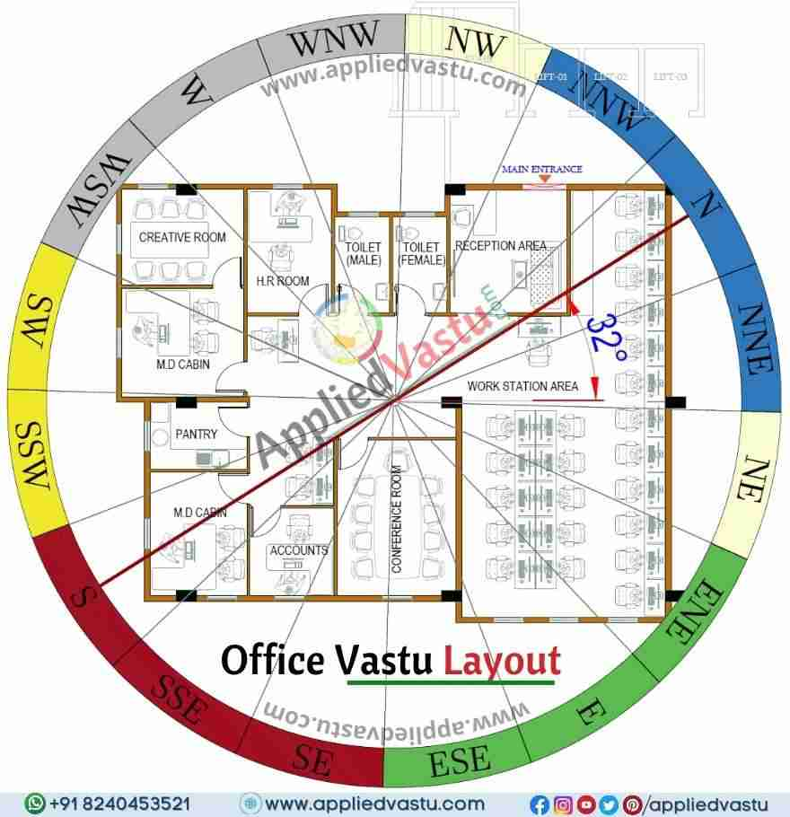
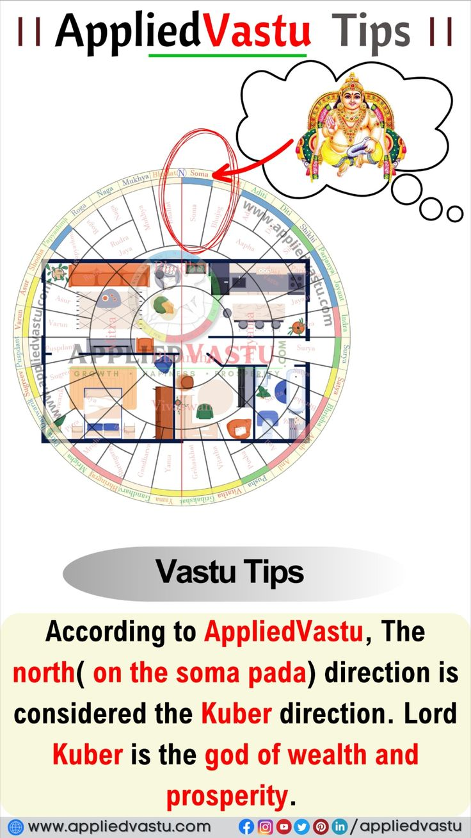
4
Governs:
- wealth
- income
- opportunities
- business growth
Element:
Water + flow
If imbalanced:
- financial block
- missed opportunities
- slow income growth

🕉️ 8️⃣ NORTHEAST (ईशान – Ishana)
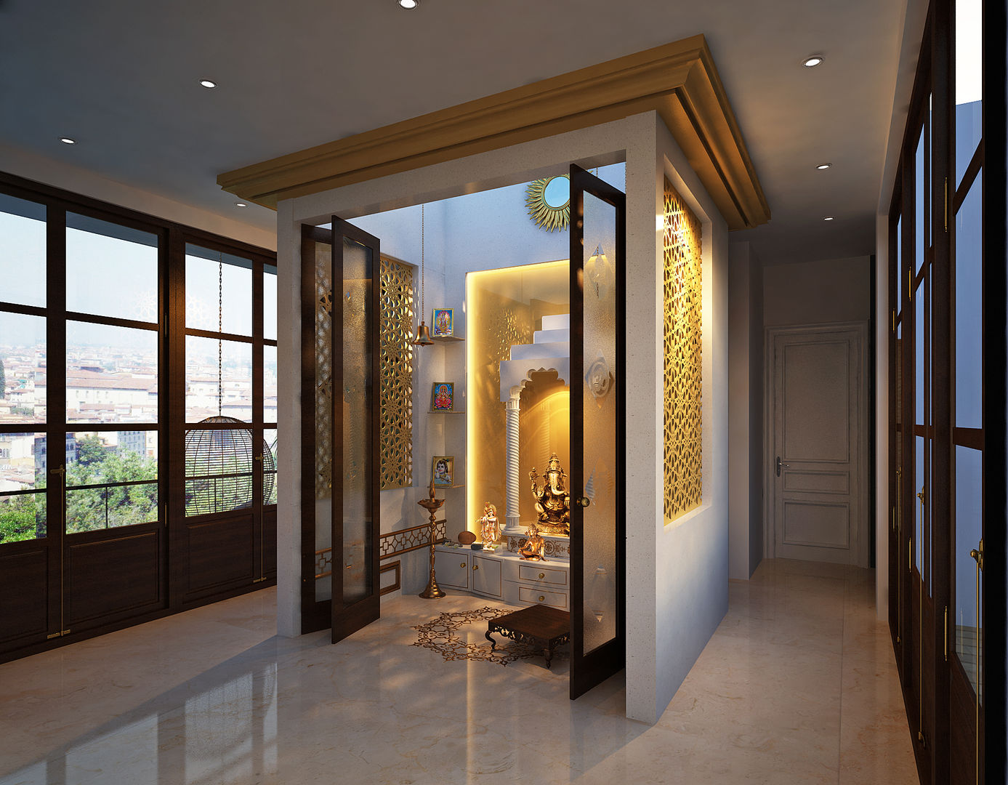

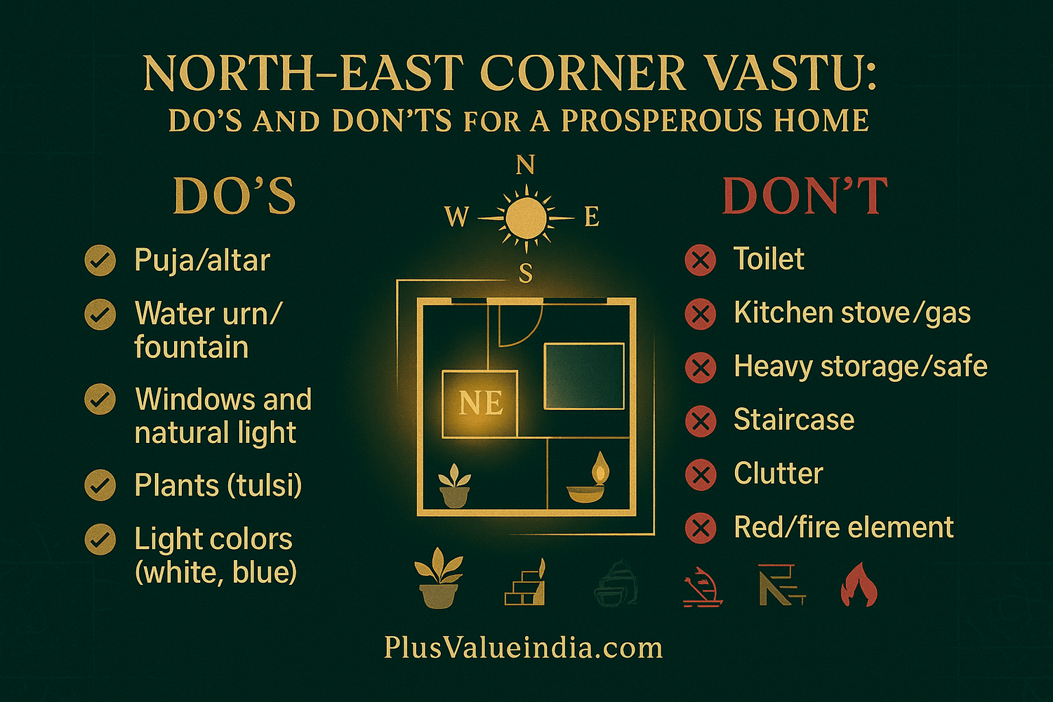
4
Governs:
- clarity
- spirituality
- intuition
- guidance
Element:
Water + space
If imbalanced:
- confusion
- wrong decisions
- lack of direction

🏆 COMPLETE SUMMARY TABLE
Direction | Governs
East | growth, recognition
Southeast | energy, health, finance
South | discipline, career stability
Southwest | stability, relationships
West | results, emotions
Northwest | movement, change
North | wealth, opportunities
Northeast | clarity, wisdom

🔥 KEY INSIGHT (VERY IMPORTANT)
Southwest = stability (foundation)
Northeast = clarity (direction)
North = wealth (flow)
If these 3 are balanced → life improves significantly.

💡 HOW TO USE IN ASTROPARIHAR
You can create:
👉 “Direction-based problem diagnosis”
Example:
- money problem → check North
- confusion → check Northeast
- instability → check Southwest

3️⃣ Vāstu acts as a silent remedy
Unlike mantra or ritual:
✔ no effort required daily
✔ works continuously
✔ supports all other remedies

4️⃣ It reduces resistance in life
When space is aligned, effort gives faster results.

⚖️ ASTROLOGICAL VIEW
Astrology (Graha) → timing & karma
Vāstu → environment
👉 Both together determine experience
“Each direction governs a specific aspect of life — when balanced, it supports harmony, stability, and growth.”

The above guidance is general in nature and based on standard astrological principles. For a more accurate and personalized recommendation tailored to your birth chart and current planetary influences, we strongly advise consulting a qualified astrologer.

